Handson 03 **– Solution**

**Create a RDS database in AWS and access it through the local client tool.**

1. RDS stands for Relation Database Service. It is a managed service.
2. Search for RDS in the services search box or select RDS from Database services.

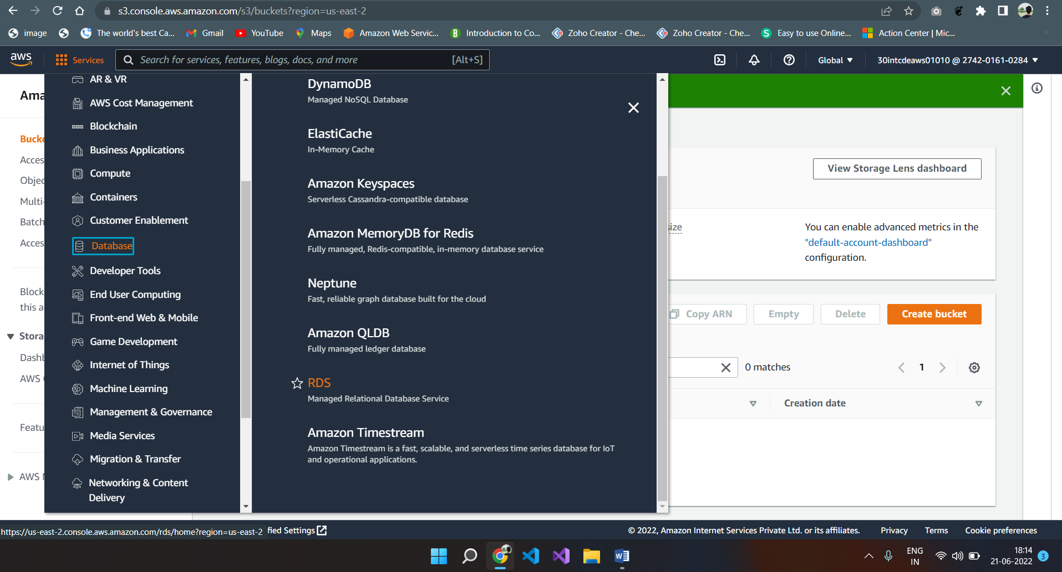

1. Click on the “Create database” button in the subsequent screen.

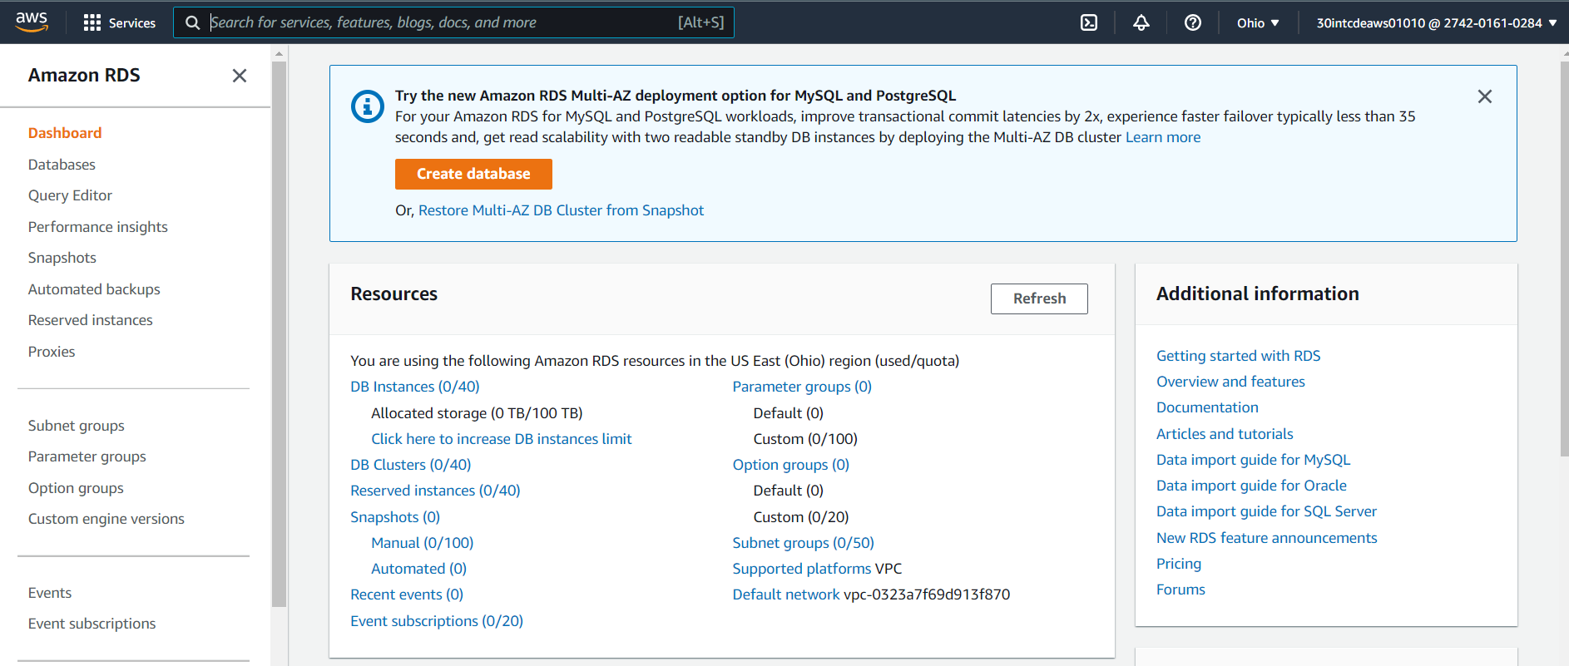

1. Select “Standard create” and from the Engine options select MySQL. You can find a variety of different database options available for you.

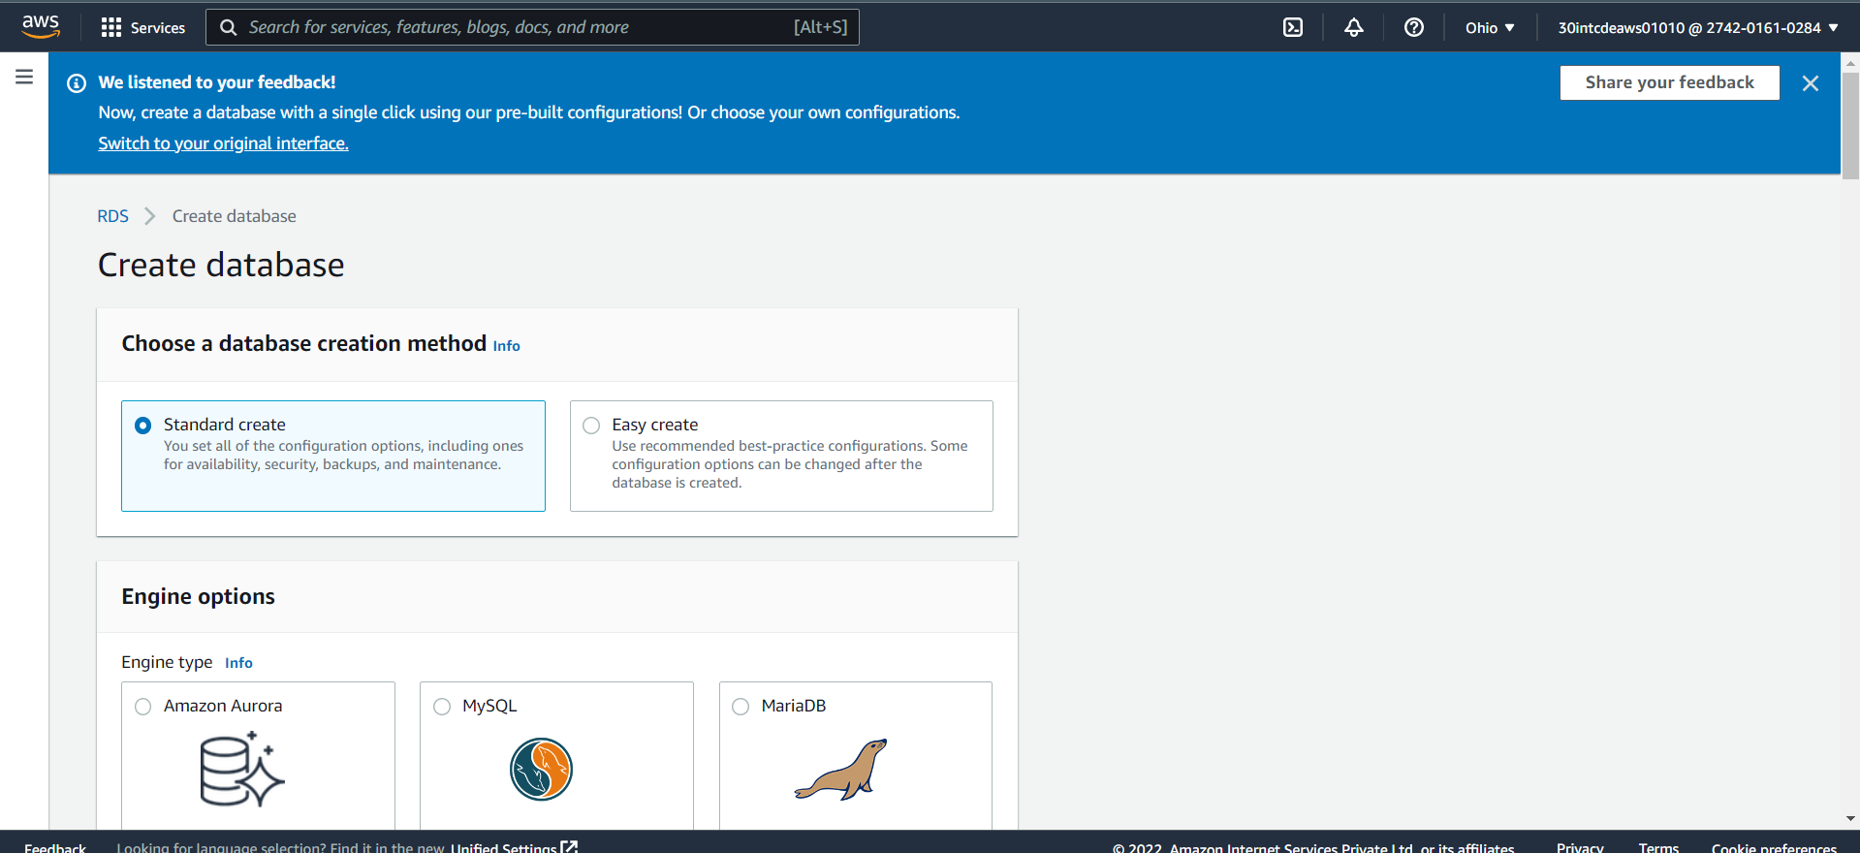

1. Amazon Aurora
2. MySQL
3. MariaDB
4. PostgreSQL
5. Oracle
6. Microsoft SQL Server
7. Select the latest version of MySQL

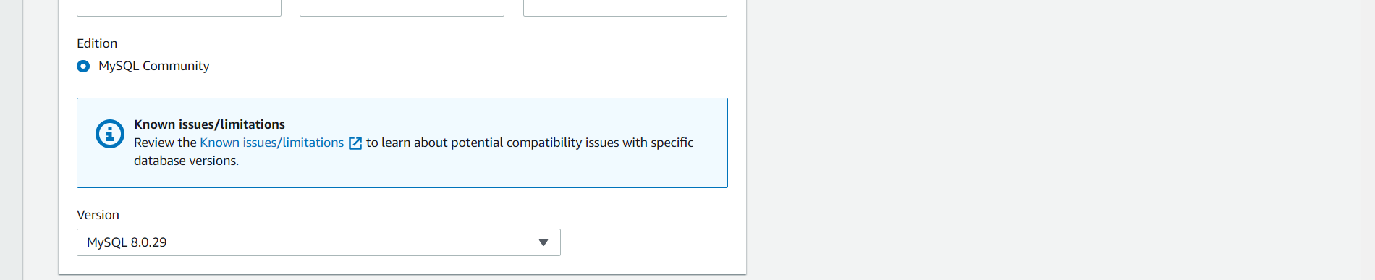

1. Then select free tier

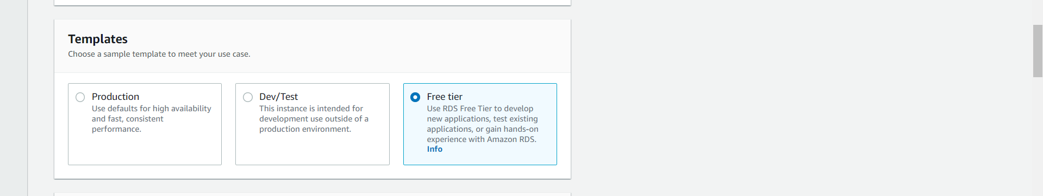

1. Provide a DB instance Identifier (This is only an Object name, not a database name).

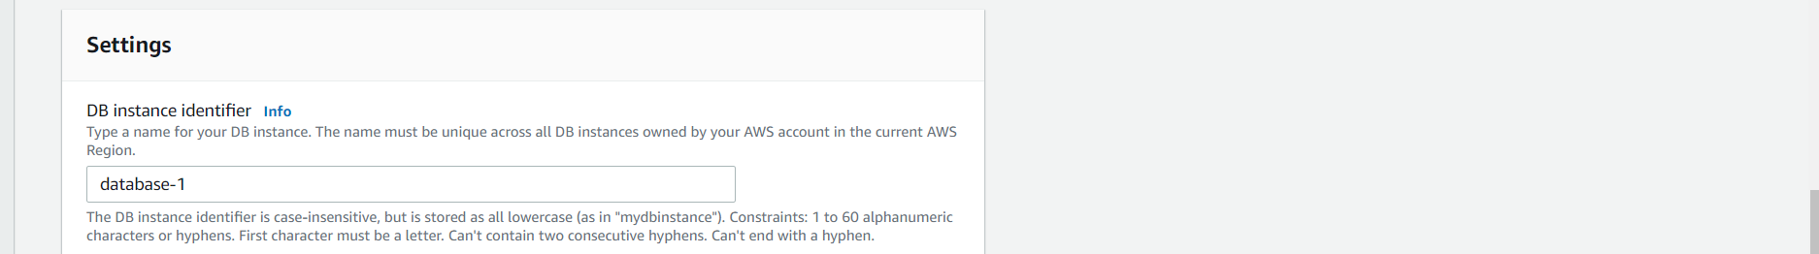

1. Provide the master username, password and confirm password.

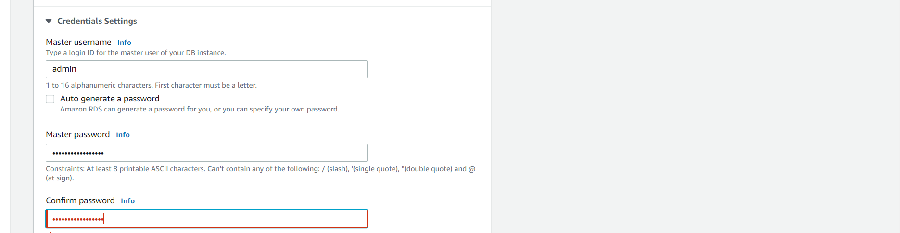

1. From the DB instance size section, select the Burstable classes option. You will get only one option with some minimum configuration since you have selected the free tire in Step 6.

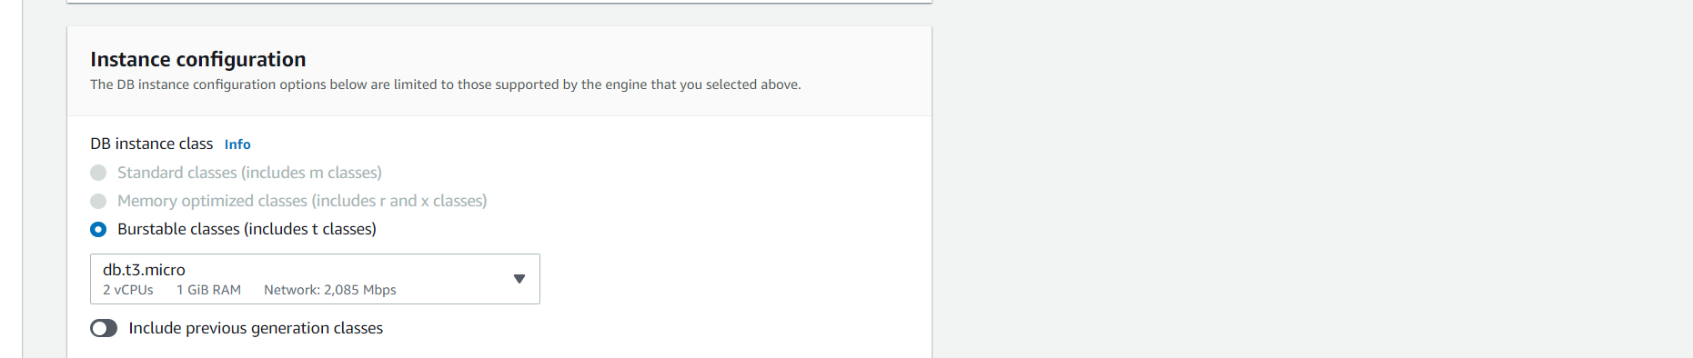

1. From the storage section, you can select the storage type, minimum storage and maximum storage.
2. You can also specify autoscaling for storage which chargeable.

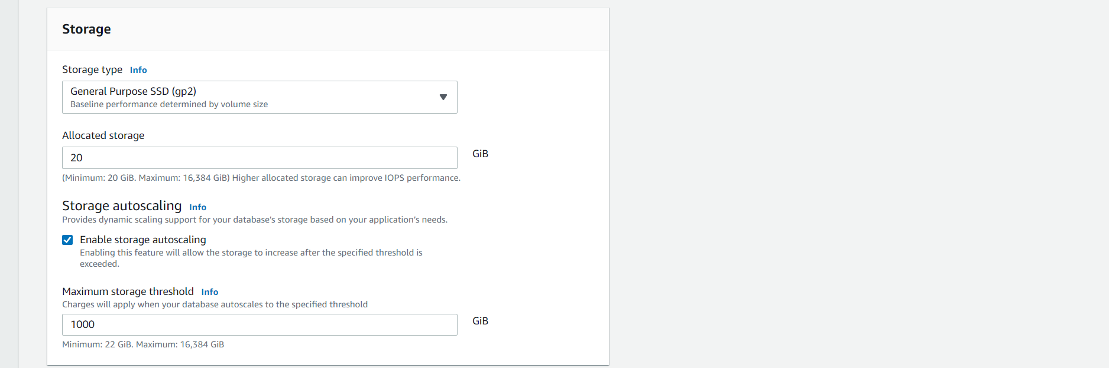

1. From the connectivity section, specify the VPC, subnet
2. Make sure that public access is set to Yes.

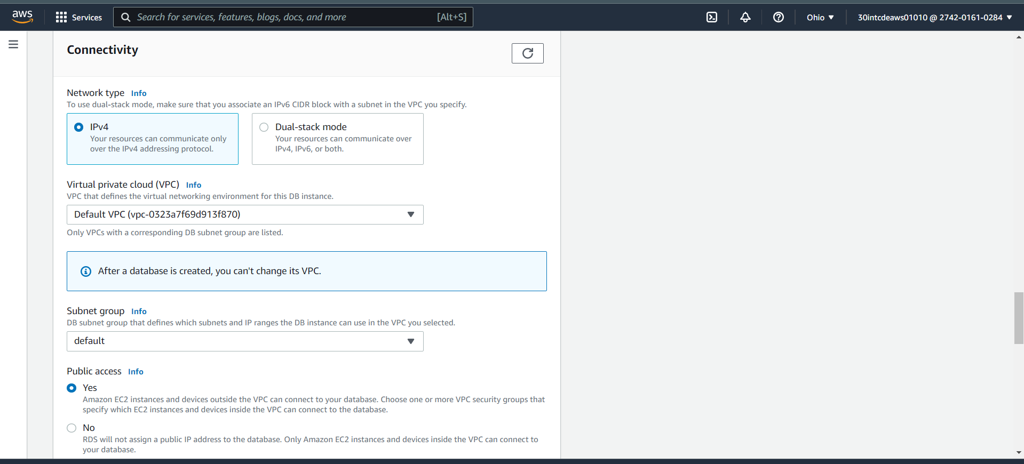

1. VPC security group select an existing security group.

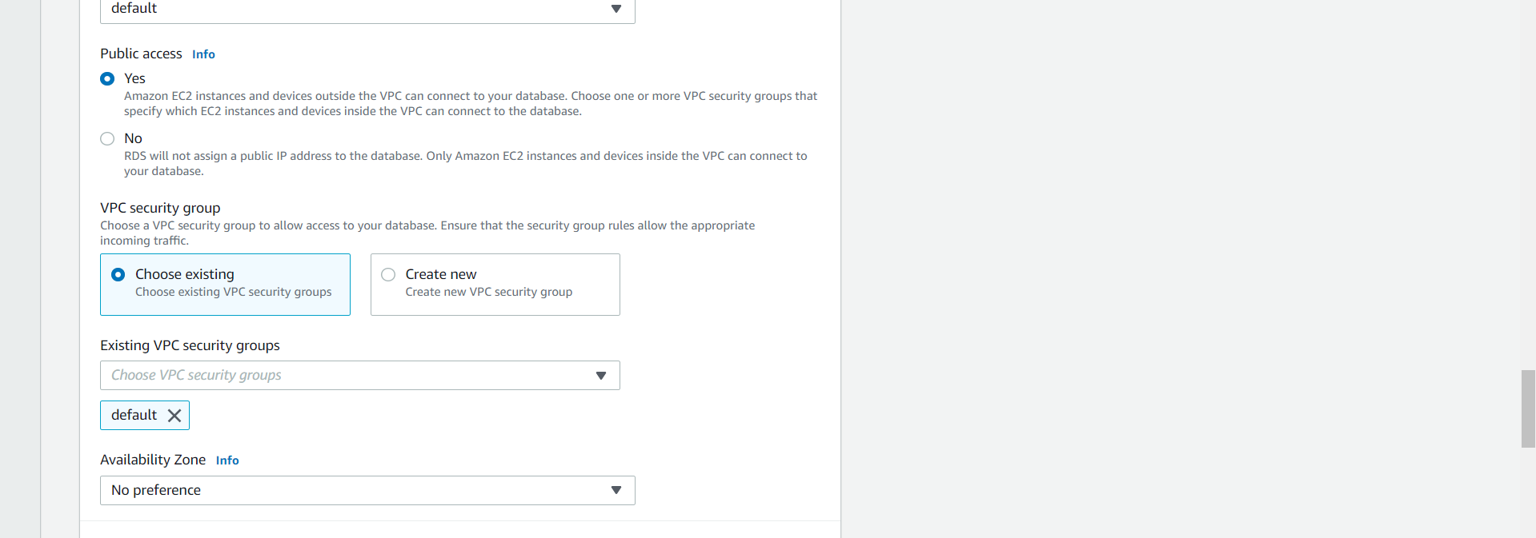

1. Accept the default for all the remaining options and click on “Create database”
2. You can see that your database is being created.

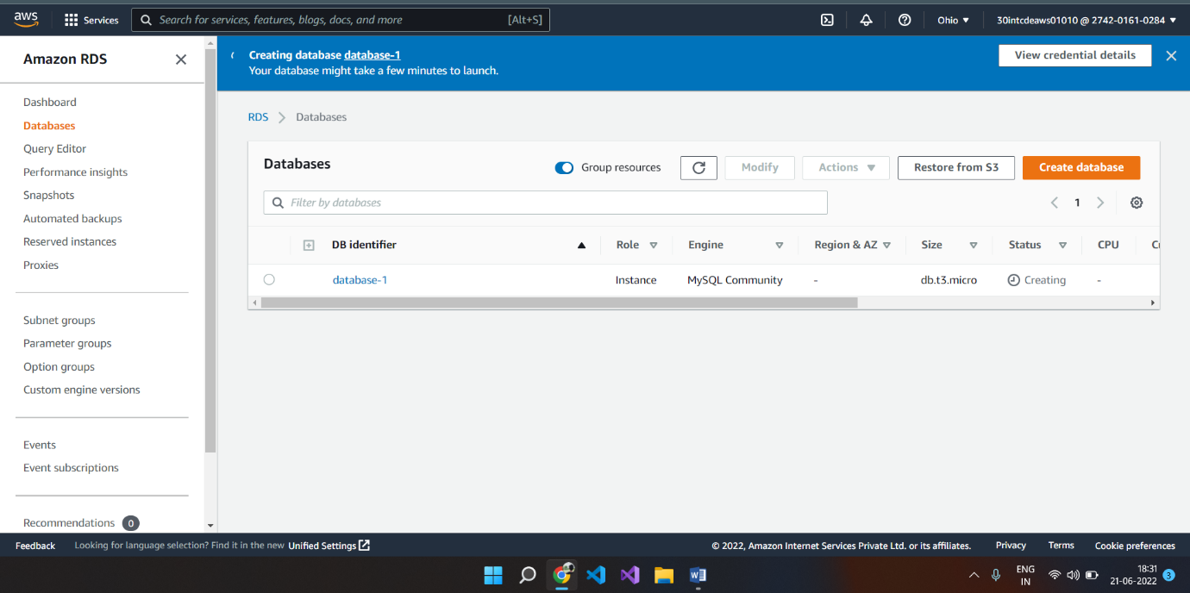

1. It will take a couple of minutes to complete the database object creation.
2. Click on the database object name

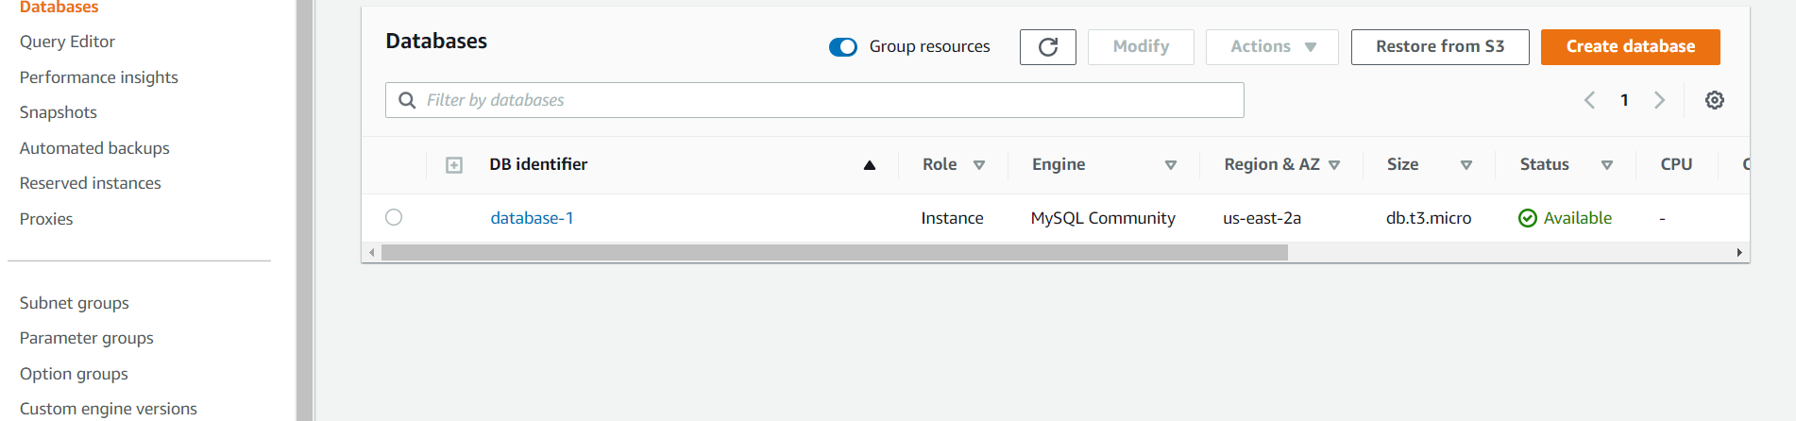

1. From the connectivity and security tab, copy the “Endpoint”

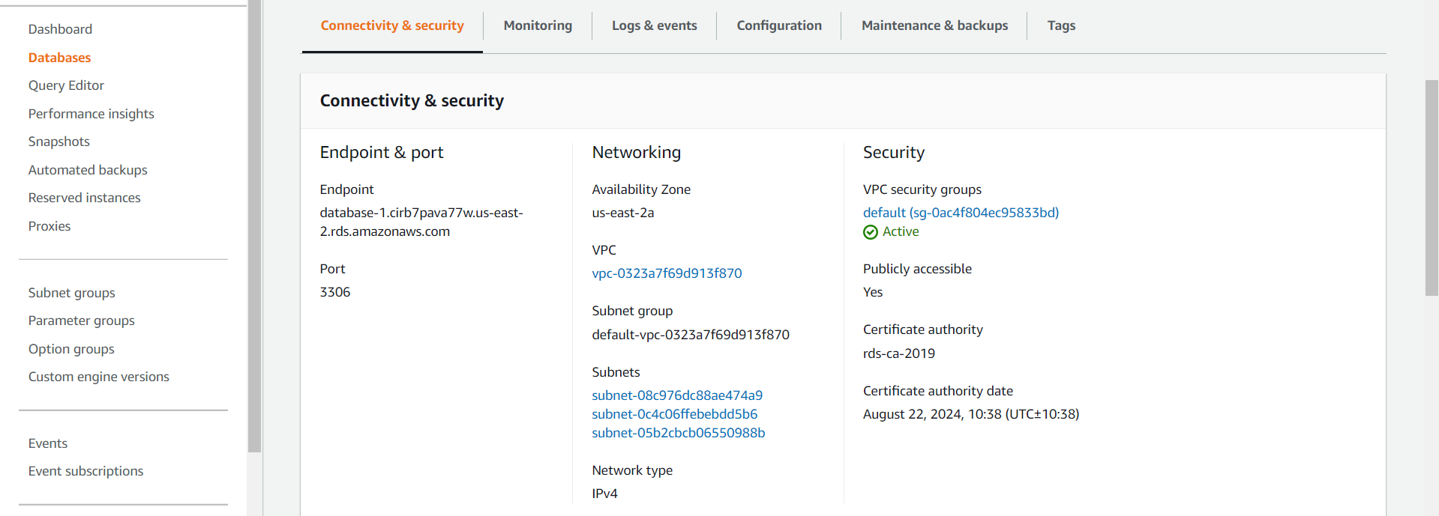

1. Now you need to select the security group.



1. Select the inbound rules tab in the next screen and click on the “Edit inbound rules” button

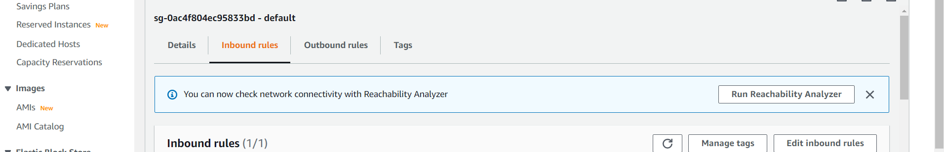

1. Click on the “Add rule” button

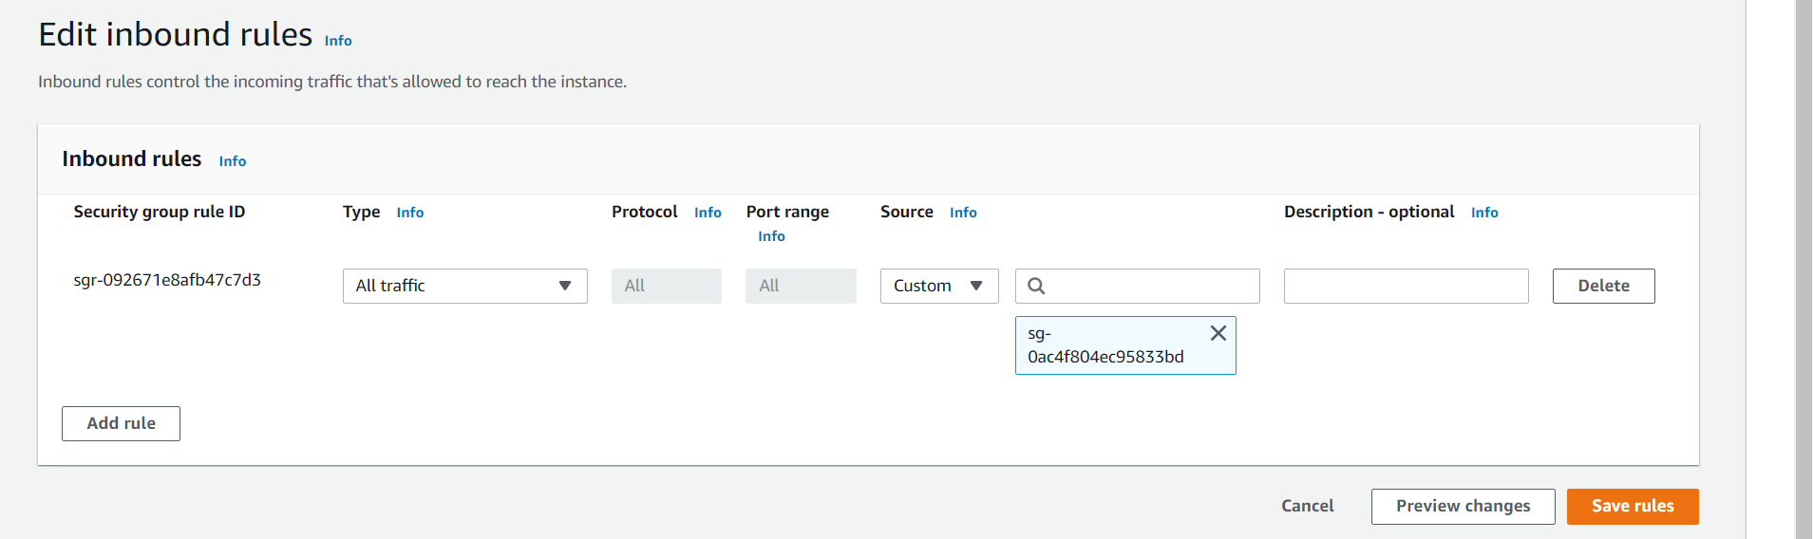

1. Add the highlighted rule as shown in the screen below

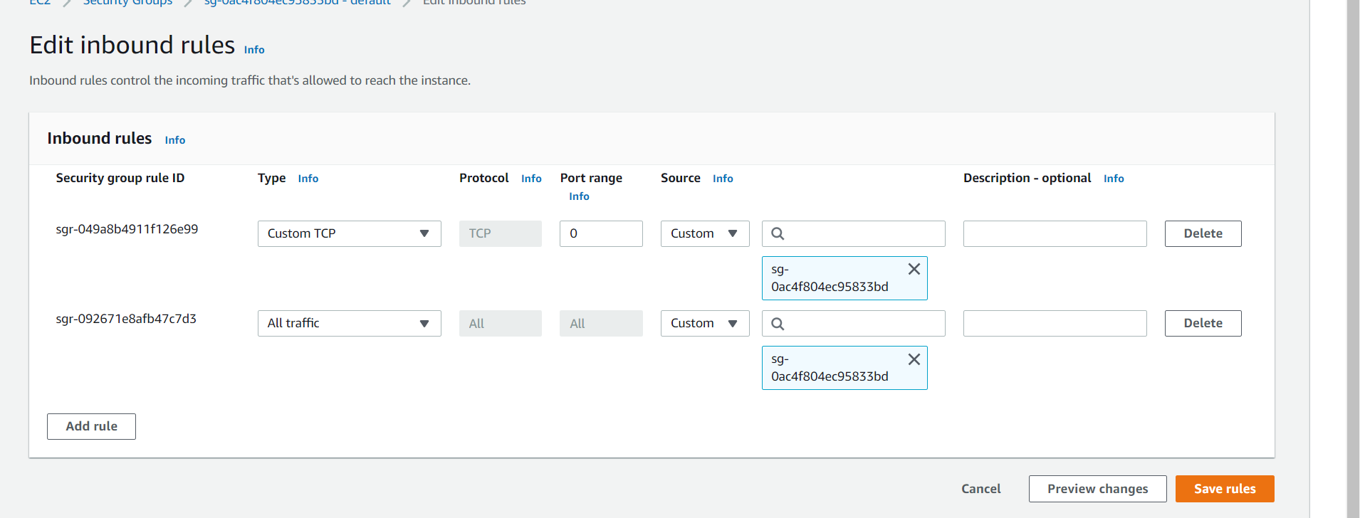

1. Click on the “Save rules” button
2. Now open the MySQL workbench
3. Click on Database=>Manage Connection

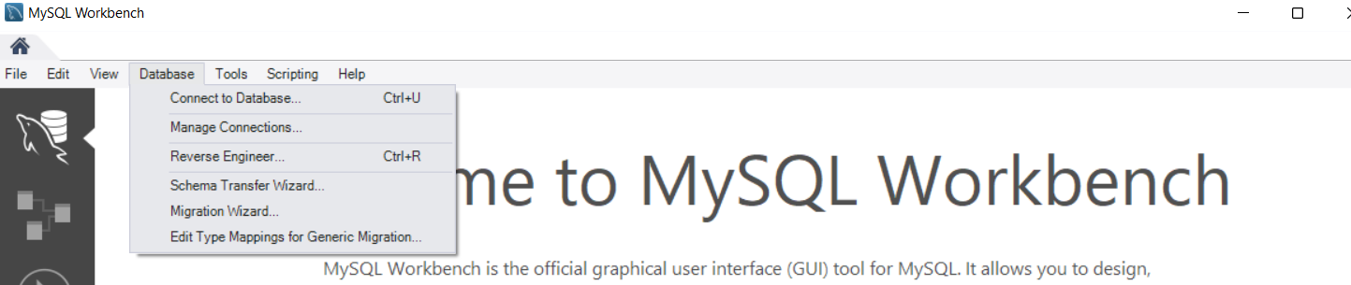

1. Click on new in the subsequent dialog box

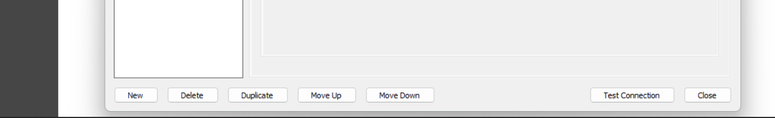

1. Select the new connection created.
2. Give a meaningful name on the connection name field.
3. In the Hostname field, paste the endpoint you copied in step 19

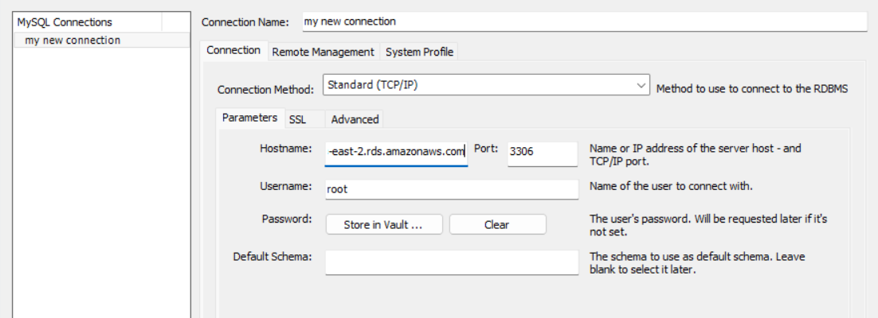

1. In the Username column, provide the master user name you have given in step 8
2. Click on Test Connection button
3. Provide the master password you have given in step 8 in the next dialog box
4. You will be connected to the RDS MySQL Server
5. In the workbench window select Database➔ connect to database
6. Give Ok in the subsequent dialog box

1. Now you can see that you are connected to the RDS MySQL server and query window is opened. Now you can issue any sql commands you  want to execute against the RDS database

**Deleting the RDS database (Please make sure you delete the RDS database once you done with your hands-on)**

1. Go to the RDS dashboard
2. Select Databases
3. Select your database my selecting the radio button to the left of your database name
4. Click on action dropdown

1. Type “delete me” in the confirm textbox and press “Delete” button

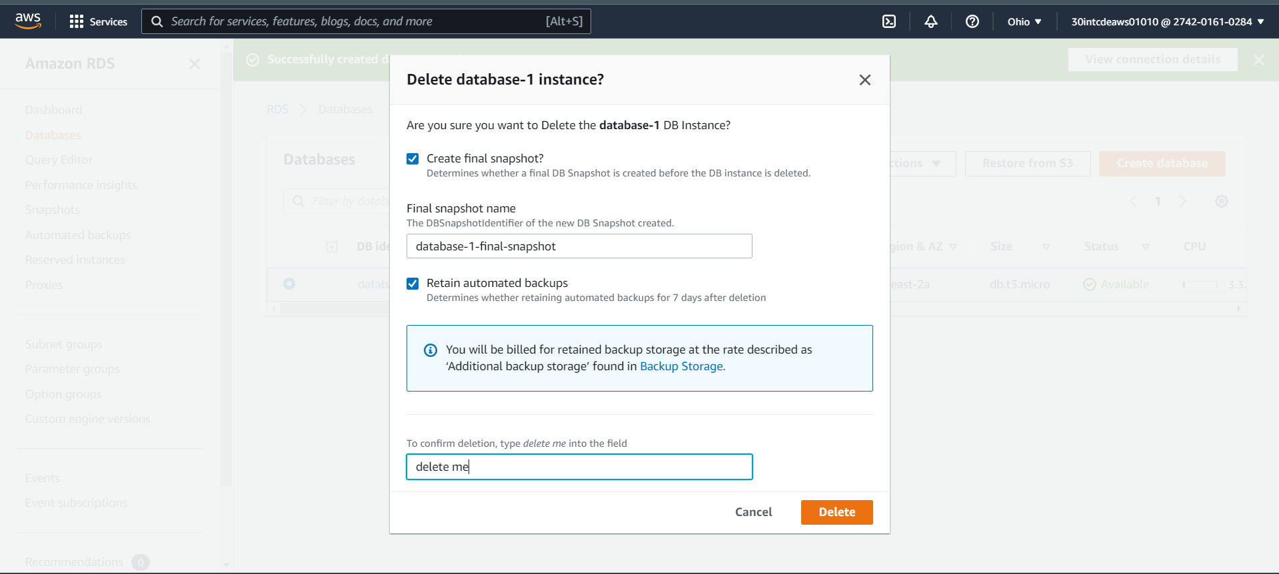

1. It will take a couple of minutes to delete the database.

